EXP NO 1: CREATE A SIMPLE CLOUD SOFTWARE APPLICATION AND PROVIDE IT AS A SERVICE USING ANY CLOUD SERVICE PROVIDER TO DEMONSTRATE SOFTWARE AS A SERVICE (SAAS).
AIM: To create a simple cloud software application and provide it as a service using any cloud service provider to demonstrate software as a service (saas).
PROCEDURE:
STEP1: GOTO ZOHO.COM
STEP 2: LOGIN TO THE ZOHO.COM
STEP 3: SELECT ONE APPLICATION
STEP 4: ENTER APPLICATION NAME
STEP 5: CREATED NEW APPLICATION
STEP 6: SELECT ONE FORM
STEP 7: THE SOFTWARE HASE BEEN CREATED.
IMPLEMENTATION:
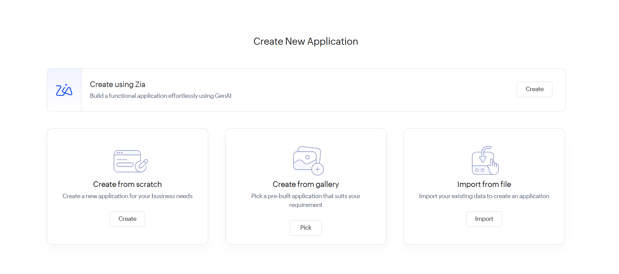
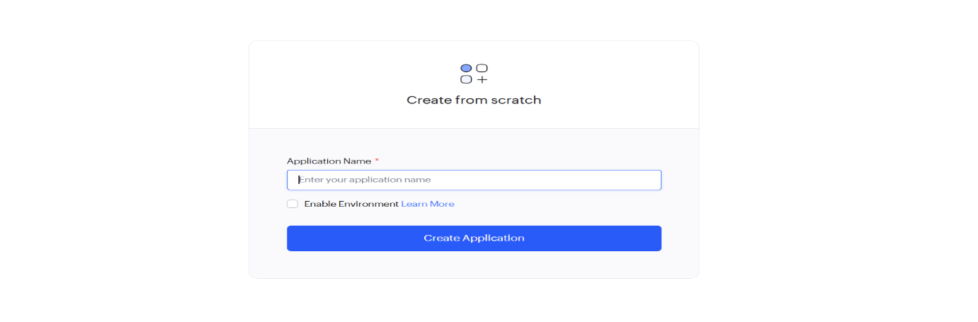

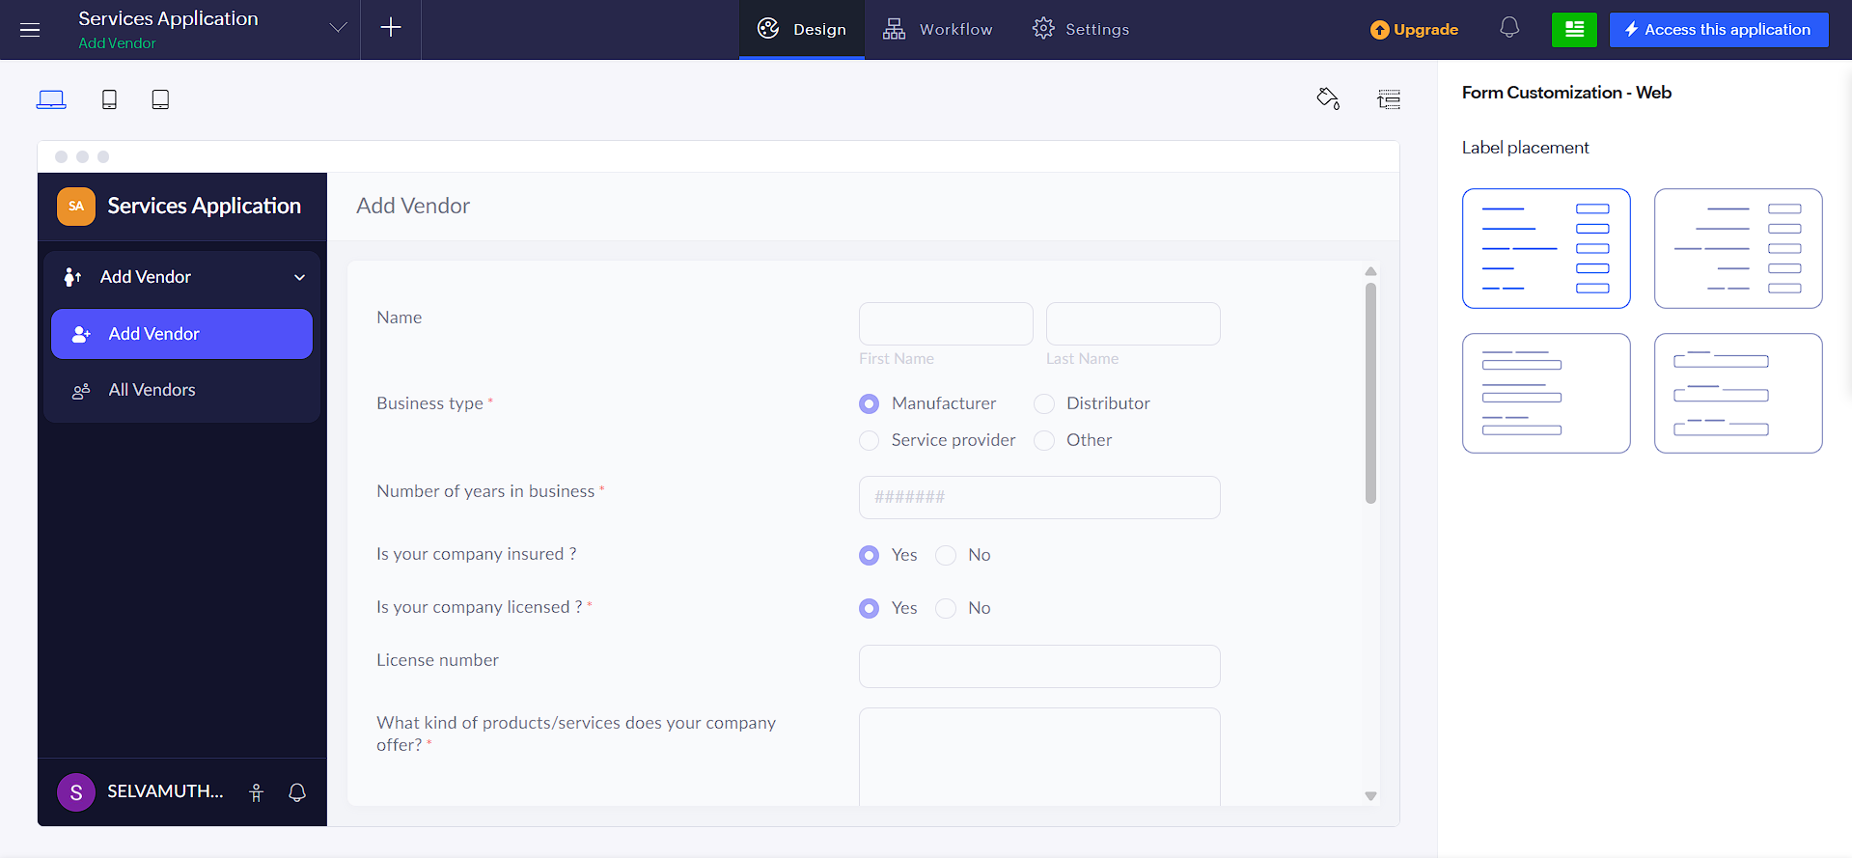
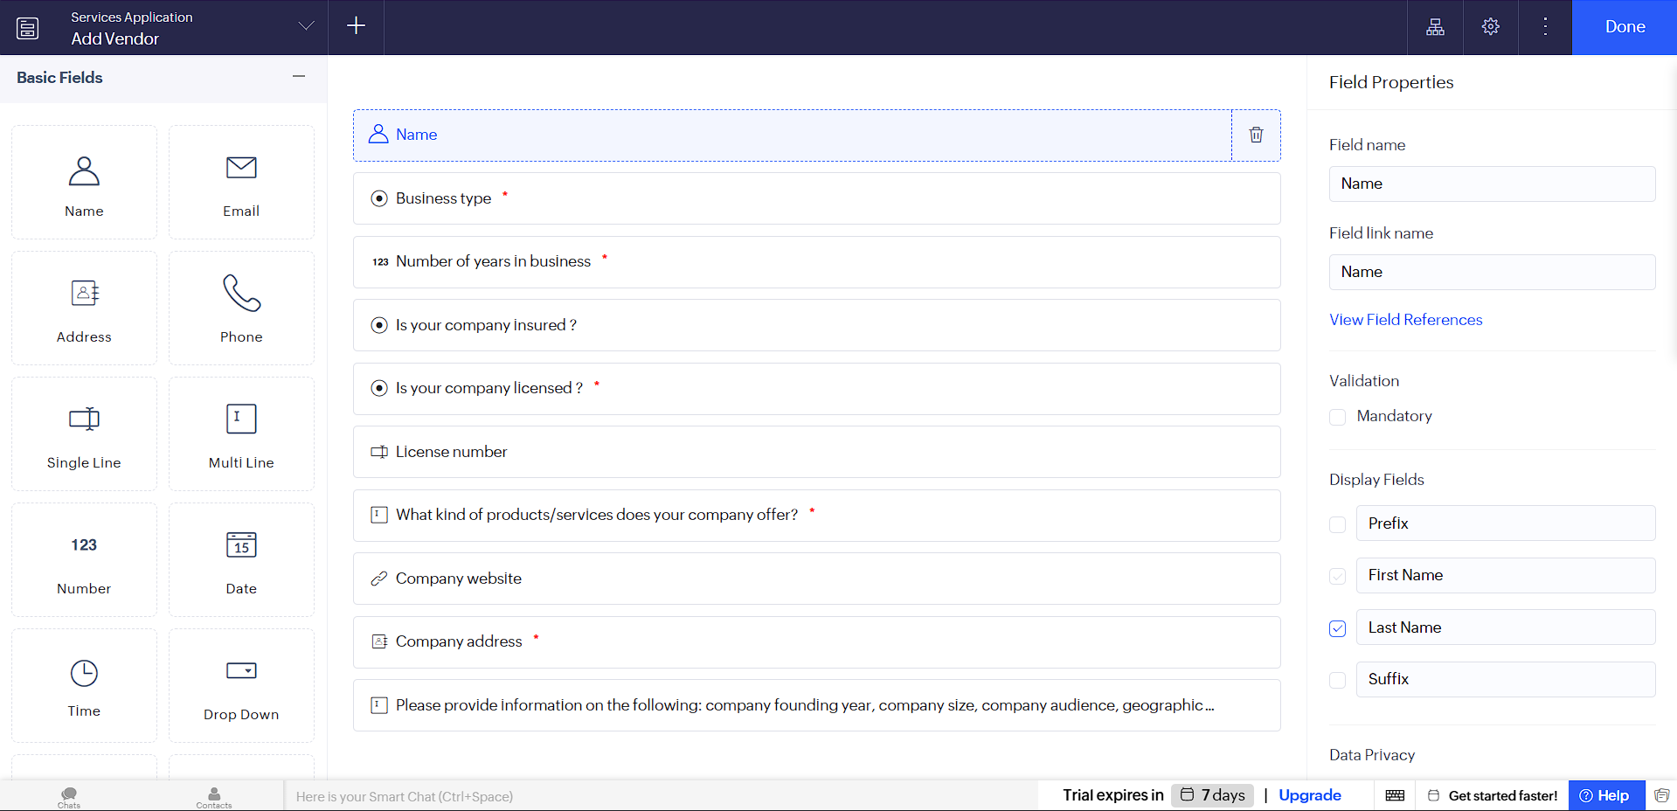
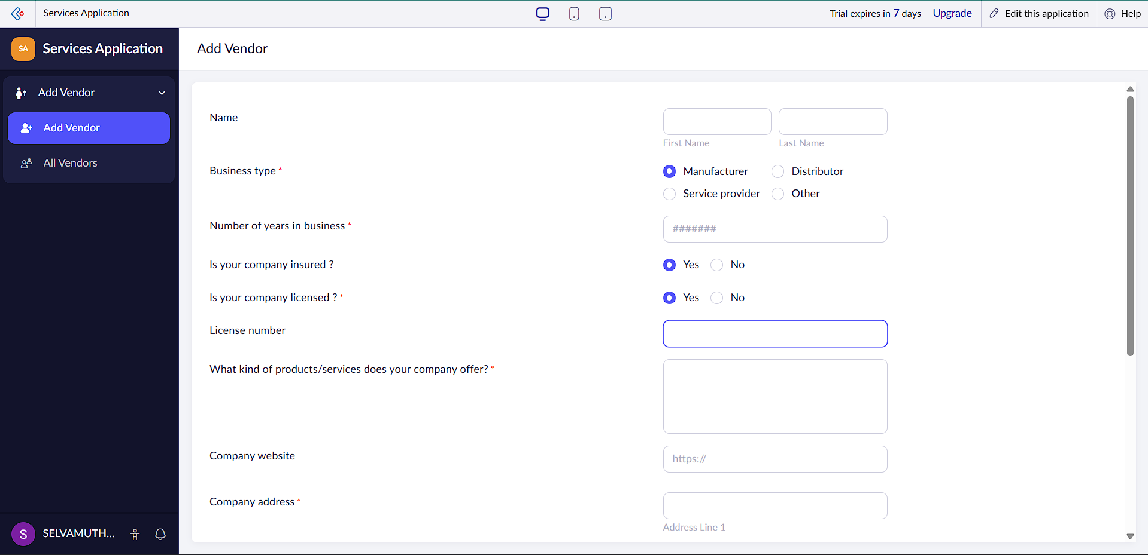

RESULT: A simple cloud-based software application is successfully created and delivered as a SaaS application, allowing users to access and use the application through the internet.

